Overview
Guidance for viewing account statements and raising disputes within the Customer Portal System.
If you have any issues and require further assistance, please email servicedesk@peelports.com
This user guide will cover:
- Activating Login for Customer Portal
- Logging on
- Viewing your Account Statements
- Create Disputes

Activating Account (logging on for the first time)
- An email will be sent to the primary email address that payments are setup currently
Example below
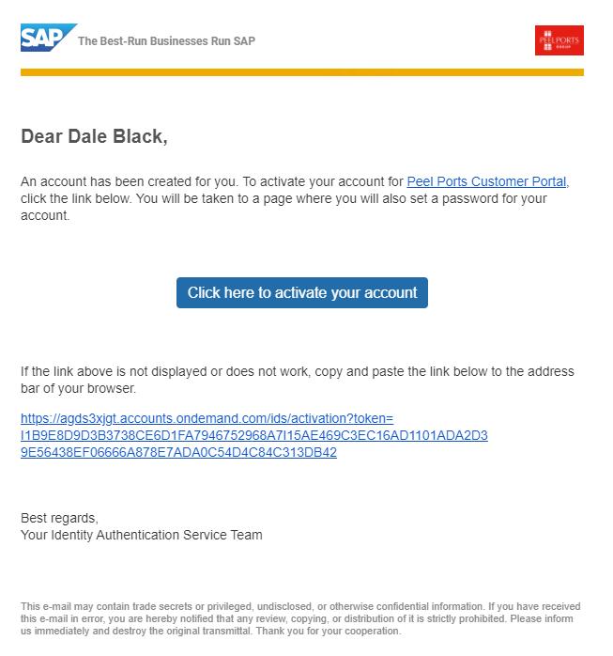

- Select Click here to activate your account
- Setup new password (Update 29/04)
Read, review and agree to terms and conditions, When reviewed Select Accept.
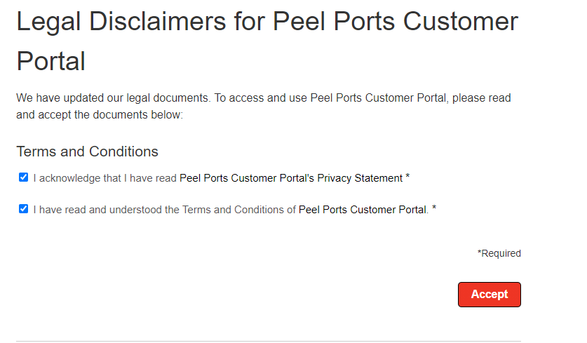

How to Log on
- Open the link for customer Portal (Insert live link when available)
- Enter Email and Password you have registered for the customer portal
- Select Log On
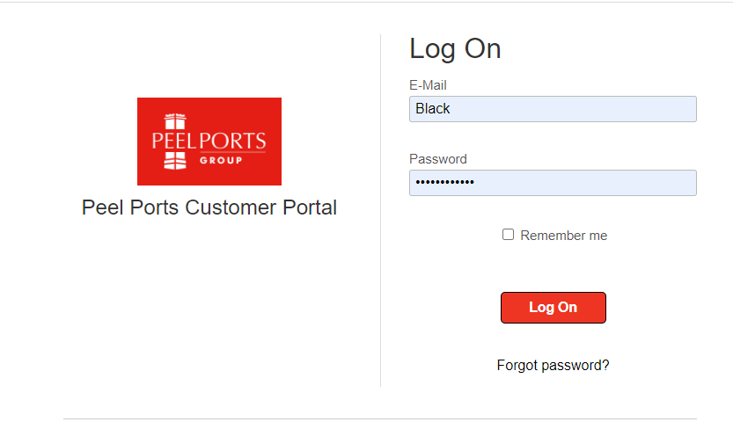
- (Optional) if password is forgotten, select Forgot Password and follow the instructions on screen.

How To View Your Account Statements
The steps below will provide guidance to be able to Allows customer to user filters to display statement data (invoices, credit memos, etc) and also view age subtotal categories.

- Logon to the Customer Portal link provided
- Select the App Display My Account Statement
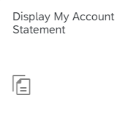
- Click Go (all items will appear, invoices, Credit memo, etc)
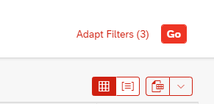

- (Optional) If you require to search for a specific item, please use the following filters:
- Account (Select account
- Status (Open Closed
- Posting Date (date the item has been posted)
- Due Date (the date the item is due)
- Document Date (the date the document was raised)
- Clearing Date (the date if cleared)
- Dispute (if there is a dispute with the item)
- Document Number (Invoice, credit memo number)
- Type (invoice, Credit Memo)
- Amount (the amount for item)

- To select a item, locate the item from the Document Number column and select the blue link.
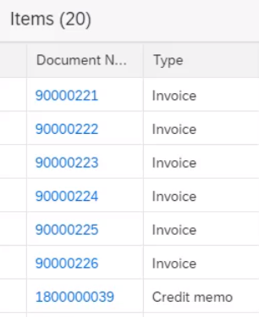
- When opened, you can view the following information:
- Info (Posting Date, Due Date)
- Items (Product Number, Description)
- Payments (If payments have been made a tab will appear)
- Attachments (If any attachments have been added a tab will appear)

Switch From Standard View (default) To Ageing View

Important -If there are multiple currencies within the aged segment you will need to expand (but no sub-total per currency is available).

- Repeat steps 8-10.
- press the icon Switch to Ageing View .

- The view will now be amended due date (example below), to view the items within the due dates, select the arrow as highlighted.
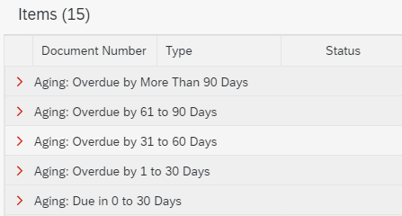

Create Disputes Within The System
This section will take you through the process of creating a dispute with any invoices, credit memos that are in the system and to be able to add a reason and attach document in relevance.
- Select the App Pay My Bills
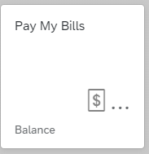
- Locate and select the relevant invoice(s) that requires a dispute creating by selecting the checkbox as highlighted.
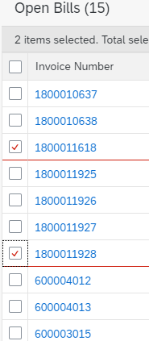
- Select Create Dispute (pop up window will display)
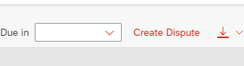

- Reason – Select from the dropdown list the reason for the dispute
- Important – Ensure the reason selected is relevant to the dispute or closest to this.
Examples below:
- Charge Waived
- Wrong Quantity
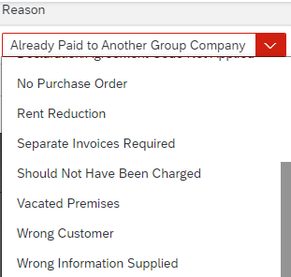

- Comment – Add in as free text any additional information for the dispute.
Important – Ensure a comment is added for the reason of dispute
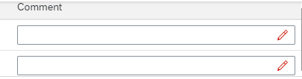

- Press OK
- It will revert you back to the previous screen showing open items, a Notification will appear to inform that Dispute has been created
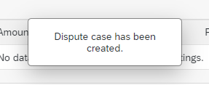
- To add an attachment select, locate the invoice and select Disputed within the Dispute column as shown.
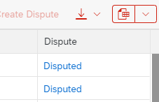
- From the next screen locate the section, Attachments for Dispute, select Upload.
- Attached the relevant file from the computer, select Open to add this
- When uploaded, you can add a comment in the notes fields.

Guide Ends

